Adaptation trial: A green light for sorghum renaissance
Wereda Asgedetsimbla is located in the north western zone of Tigray. It is one of the sorghum potential areas in the region. For the past many years, farmers themselves were source of sorghum seed varieties. They keep different seed varieties and exchange in kind during plantation season. However, due to agro-ecology adaptability problem and repeated climate change occurrences, the performance of local seed varieties declined from time to time.
BENEFIT collaboration in sorghum adaptation trial
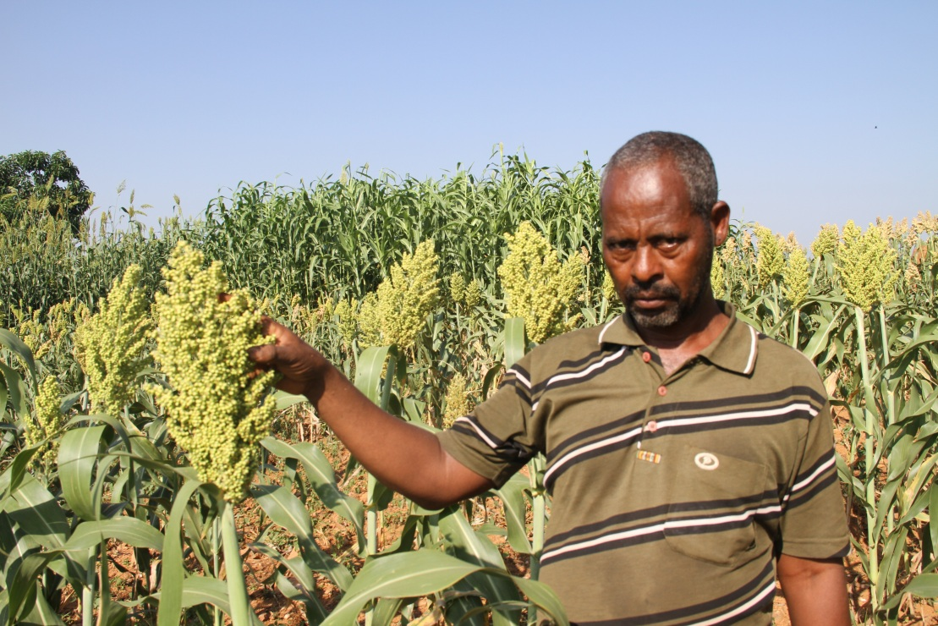
In 2017 fiscal year, an action plan among BENEFIT partners (ISSD, CASCAPE & SBN) was facilitated to provide farmers with improved seed varieties. As part of this partnership, a pilot collaboration based on adaptation trial accomplished on sorghum in Asgedetsimbla wereda at tabia level. In these three tabias namely: Dedebit, Selam and Hitsats; there are nine farmers engaged in the adaptation trial on sorghum seed varieties. Among them three are women headed farmers. At the end of June 2017, each farmer was provided with 150 gram of six different seed sorghum varieties [25 gram for each variety] for demonstration. Using the same technique acquired through practical training, all of them planted those seed sorghum varieties on six equal plot sizes. This collaboration endeavor shows farmers green light in supplying improved and/or farmer preferred sorghum seed varieties.
Tesfay showing well performing seed varieties
Tesfay Gidey, 52 years old, is one of those farmers who are engaged in the adaptation trial on sorghum seed multiplication. From the given six different sorghum seed varieties for adaptation trial, that Tesafy observed four varieties performed well and two failed due to late maturity. Concerning the newly deployed sorghum seed varieties (Melkam, Meko, Dekeba, Tewzale, Leli and Tetron) and the existing ones farmers are using; Tesfay said “comparing with the varieties we had, the newly introduced sorghum seed varieties seem superior quality. Especially Melkam, Meko, Dekeba and Tewzale are agro-ecologically fit varieties for our locality. They are early maturing varieties with encouraging amount of yield to cascade as best sorghum seed varieties. They seem more climate smart varieties than the old varieties. Over all, it needs profound investigation and trial to decide all traits they owned and then distribute to other farmers.” He added Leli and Tetron are late maturing and need long maturity period to harvest. Hence, two of them failed in the adaptation trial.
The four well performing sorghum seed varieties and Tesfy’s ranking
Variety name (deployed) | Amount harvested (kg) | Traits observed (farmer level) | Rank
Melkam | 9.5 | Short, thick, huge spike and palatable for animal feed | 1st
Meko | 12.5 | Early maturing, attract birds | 2nd
Dekeba | 7.5 | Small seed size, thin | 3rd
Tewzale | 30 | Not socially accepted due to bitter taste | 4th

Tesfay told that more than 200 individual farmers visited his farm level adaptation trial at different times. Wereda office of agriculture organized farmers’ field day and invited 182 farmers [123 male & 59 female] to visit Tesfay’s plot. Split into groups, the farmers came from different tabias of the wereda and observed the adaptation trial mechanisms Tesfay used. Farmers asked him about the management practice he followed specially plowing, weeding and inputs application procedures. In addition to the experience sharing visit conducted at wereda level, some farmers in the neighborhood were attracted by the performance of the seed varieties deployed.
Regarding farmers visit, Tesfay stated: “while passing through the trial site farmers stop for a while and talk among one another about the varieties and their source. I explained to them BENEFIT provided the varieties. Before planting, I tilled the land three times and weeding three times. Most farmers want to have Meko variety due to its early maturity trait. However, I myself rather prefer Melkam due to its big spike, short height and its quality for forage. I planned to distribute the seed to five farmers.”
Finally, Tesfay commented on the delay of sorghum seed deployment time table and recommended early deployment is important for all kinds of preparations.

